


2nd BULLETIN

ISTANBUL BAGCILAR OLYMPIC
SPORT HALL

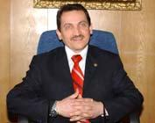

Dear Friends,

We have the honour to invite your National Karate Federation to the 5th
World Cadet and Junior Karate Championships, which will be held in
Istanbul on 19-21 october 2007.

We hope that all the participants will be satisfied with their visit and
participation in this professionally organized sports event in Istanbul.

We are looking forward to meet you in Istanbul/TURKEY.

Yours Faithfully.

Mehmet ATALAY
The General Director of
Youth and Sport General Directorate

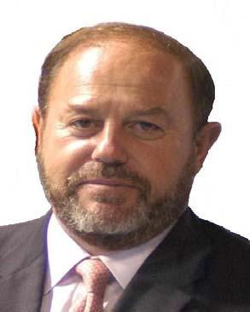

It is for me and for all of the components of the World Karate
family a great pleasure to visit Istanbul and Turkey. More than 80 World
countries are going to meet in Istanbul around Karate, a sport that is
proving day by day not only how deep it is merged in our society but also
the added value that its practice gives irrespective of age and condition.

Turkey is a very important piece of the European Karate
Federation and also of the World Karate Federation, for both qualitative
and quantitative reasons. We have lived the progress that karate has
experienced in this country and how positively it has been contributing to
the worldwide development of our sport.

I also want to congratulate the Turkish Karate Federation for
the commitment, professionalism and interest shown for the successful
organization of these Championships, and wish that this event will serve to
further promote karate popularity and practice throughout the country.

In the name of the whole World Karate, I want to thank you for
your inestimable contribution, and I am sure that we all will enjoy
unforgettable days in Istanbul.

Antonio Espinós
The President of
World Karate Federation

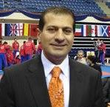

Dear Friends,

Welcome to the hometown of the 5th World Cadet and Junior
Karate Championships from October 19th to 21st 2007 in Istanbul.

We are very happy to host the World Championships in the city
of Istanbul which is connecting the Asian and European continents. I hope
that all of the delegations will leave Istanbul with unforgettable memories
of friendship, love and peace.

Sincerely yours,

Aydoğan ÇELİK
The President of
Turkish Karate Federation

Aydoğan ÇELİK The President of Turkish Karate Federation

Necati ÖZER Member, Deputy President

İrfan KAL Member, Vice President

Musa ERTUGAN Member

Ercüment TAŞDEMİR Member

Contact Information;

Turkish Karate Federation

Ulus Ishani Kat 5 Ulus Ankara

Tel: +90 312 310 61 90
Fax: +90 312 309 32 62

Mobile: Aydoğan Çelik +90 533 277 36 11

Ercüment Taşdemir +90 533 632 18 52

Email: worldkaratechampionship@turkishkaratefederation.net

www: www.worldkarateistanbul.net



Turkish Airlines THY runs competitive flights to Istanbul from all over the world, alongside the major national carriers, though in some cases from other continents it may prove worthwhile to take a cheaper flight into Europe and to take a connecting flight from there.
From northern Europe, the distance, the steady rise in popularity of Turkey as a tourist destination, and the visa restrictions of Bulgaria and Romania combine to make travel by air often the cheapest, and by far the most convenient, direct route to Istanbul. Those with an eye on their budget should scan newspapers and travel agents for huge discounts and charter flights, especially, but not only, during the tourist seasons, and will probably find the effort very well rewarded.

On arrival at lstanbul Ataturk Airport there is a rapidly improving bus service (HAVAS) to take you through Aksaray to Taksim. Also, you may always use your attentive taxi driver, which is not too expensive either.

Visit for more info www.thy.com

By Car ;

By car there are likely to be similar border concerns, and visas should be looked into well in advance of crossing the Balkans. The most attractive route is to park your car on a boat in Venice for a more relaxed Mediterranean voyage to Izmir, where you'll be able to compare the Italian style of driving with the Turkish as you head up the Aegean coast to Istanbul. For entry into Turkey, an international driving license and insurance are necessary, and for tax purposes the same car must be with you when you leave.

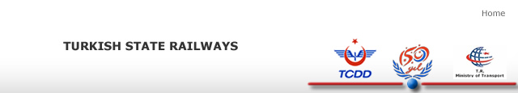

By rail, too, you can normally arrange to break your journey and explore the lands you are crossing, but with flying a cheaper alternative, then unless you have a specific destination en route, train travel should only be considered by those with a deep fear of both flying and buses. For the incurably romantic with plenty of money and little sense of direction there is always the Orient Express, but unfortunately it no longer goes as far as Istanbul and you'll have to make your own way from Venice.

The scope of this guide stops at saluting and wishing well the bold and energetic few who are already convinced to undertake the journey by bicycle.

Orient Express :
Inaugurated in 1883 by a French railway company the Orient Express soon became the stuff legends are made of. Originally travelling from Paris through Munich, Vienna and Sophia to the Slrkeci station of Istanbul, passengers could continue the journey, traveling by boat across the Bosphorus to the Haydarpasa Railway Station to join the Taurus Express to Anatolia. Although the route varied throughout the years it ran from Paris to Istanbul, a distance of 3186 kilometers. A monument to the hedonistic days of the late 19th and early 20th century it was the most luxurious long distance rail journey in the history of travel. Royalty; aristocracy; the rich and the famous traveled regularly on the Orient Express. Its passenger list read like a volume of "who's who". Gourmet chefs, chandeliers, fully equipped bathrooms, staterooms and dining rooms on par with the Ritz were all part of the train. It takes on a myth like quality in our current times of `functional' travel. Woven into the plot of many books, it is remembered today mainly through Agatha Christie's book (and later a film) "Murder on the Orient Express“.

The Orient Express slowly declined in the 1930s with the Simplon Orient Express and the Arlberg Orient Express partially replacing it. ln the 1980s the Orient Express was re-introduced by entrepreneurs running from Paris to Vienna (1390km) and from Stuttgart to Prague (1253km). The "Orient Express" surely being a misnomer for these routes.. Unfortunately in the 1990s we are more interested in the speed we can reach our destination rather than the journey itself. The days of opulent train travel are long gone but the mere mention of the name Orient Express still evokes visions of past glories.

For more information www.tcdd.gov.tr

The hotels, contracted for the World Championships, are located in the city centre of Istanbul.

All reservations must be made before the September 21st, 2007.
The number of rooms available is limited and a first come (with a downpayment of 100% paid/first serve policy will be followed.

CANCELLATION CONDITIONS:
At least 60 prior to arrival: free of charge
45 days prior to arrival: 25% of the total price for the booking
30 days prior to arrival: 40% of the total price for the booking
15 days prior to arrival: 75% of the total price for the booking
7 days prior to arrival: 100% of the total price for the booking

Please also note, when making changes to your initial reservation, the first change is free of charge, from the second change onwards, the charge is 50,00€/change to cover office fees.

DEADLINE FOR RESERVATIONS IS

September 21st,2007

Hotels, transfers and entry tickets can be booked only through the Turkish Karate Federation

Turkish Karate Federation
IBAN NO: 66 OOO1OOO683 466O4964-5OO3
SWİFT CODE : TC ZBTR2A
Bank address: Ziraat Bankasi Ulus Branch
ULUS/ANKARA TURKEY

Email: worldkaratechampionship@turkishkaratefederation.net

Sales marketing enquiries

Please address all subject enquiries to

Mr. Ercument Taşdemir Mobile +90 533 632 18 52
Fax +90 212 310 24 36
Mail tasdemir@turkiyekaratefederasyonu.com

General enquiries & correspondance

Please address all correspondance to:
Turkish Karate Federation
Ulus İşhanı Kat 5 Ulus
Ankara (Turkey)
Tel: +90 312 310 61 90
Fax: +90 312 309 32 62
Email: worldkaratechampionship@turkishkaratefederation.net
Transfer prices

Airport – official hotels - airport (prices in Euro (€) per person);

1.Transportation between airport and the official Hotels and return will be offered at the price of 30 Euro per person.

2.You might prefer a daily rent vehicle:

* 00-04 persons : 150 Euro
* 12-18 persons : 400 Euro
* 18-24 persons : 475 Euro
* 24-40 persons : 550 Euro

Transfers between the official hotels and the competition venue will be free of charge on competition days and the shuttle service will be made each hour.
3. Turkish Karate Federation will found a Restaurant with open buffet in the Bagcılar Sport Hall and the open buffet food price is 15 Euro.

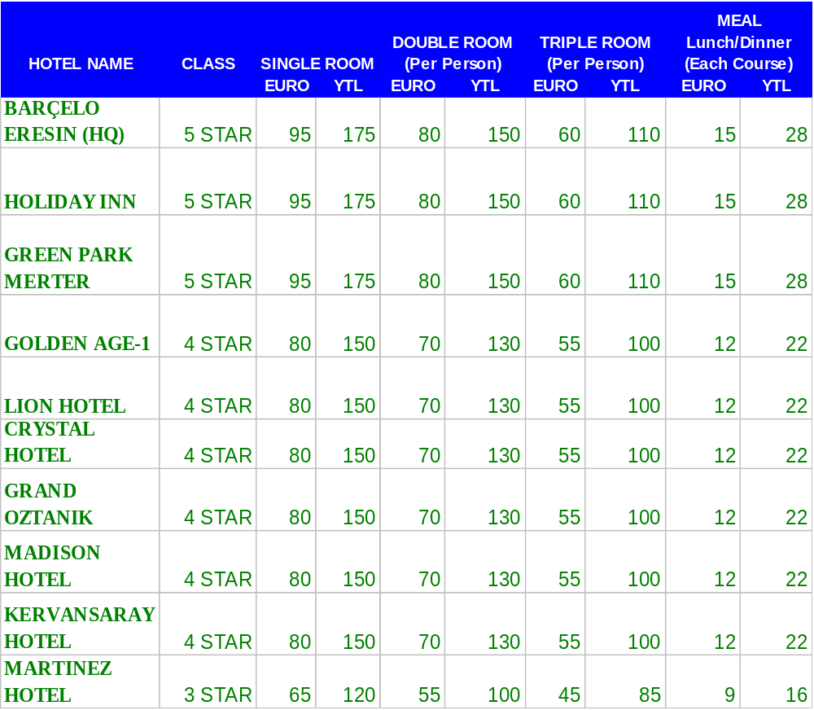
Prices include accommodation and breakfast,
Please note:
The shuttle bus, free of charge, operates only between
official hotels each hour during the competition.

Training Facilities

The organisation will provide the countries, which make the relevant application
in time, with a place for training, from the 16th to the 18th of october 2007, both
days inclusive. This application must be received before the September 21st of
2007. Training area and transport for those training participants, will be arranged
in a nominal charge. Transport will only be available from the official hotels.
Entrance tickets

The organisation will provide the National Federations with a quota of entrance
tickets for the World Championships with the following special low rate of 40
Euros/per person for the whole competition period of three (3) days.
Farewell party

The party will be held at the HQ hotel on the 21.10.2007 from 20.00hrs. to 24.00 hrs.
The entry ticket covers entrance, free transportation from and to all official hotels, all
night buffet dinner and the first drink of choice. The ticket price is 35,00€ per person.
Tickets will be sold in the Turkish Karate Federation stand at the Sporthall.
All the payments will be done in Euro (Currency) in cash upon arrival in Istanbul to
the Organising Commitee.

Media, TV

The WKF has all the rights related to the World Karate Championships. It means
that only the persons with WKF’s permit can take professional photos or videos in
the competition. In other words e.g. cameras/video cameras with tripod are
prohibited in the sports arena. Should you need more information about press or
media related issues, please contact the World Karate Federation´s office in
Madrid.

Other relevant information

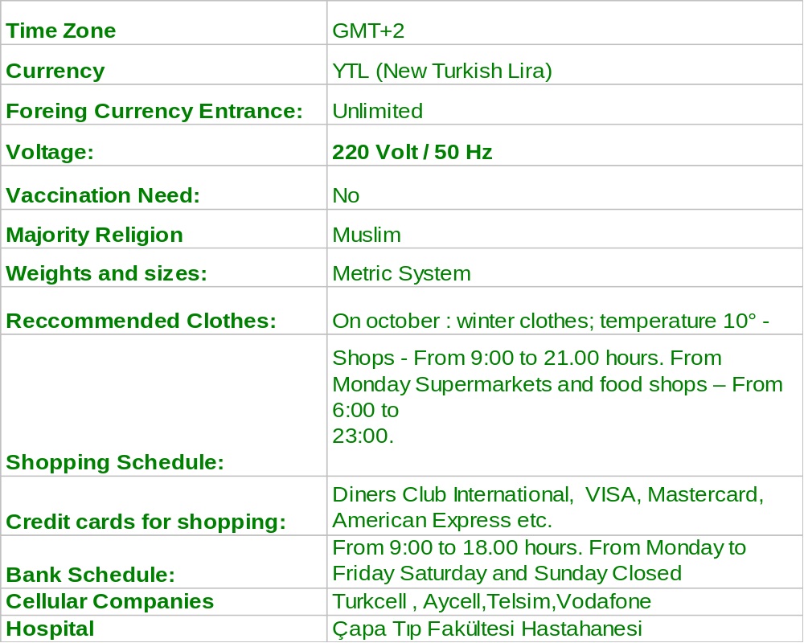
Useful Web Sites and Numbers :
General Directorate Youth and Sport www.gsgm.gov.tr
Turkish Airlines www.thy.gov.tr
State Railways www.tcdd.gov.tr
Police 155
First Aid 112
Info 11811

Referee Course Activities

Dates | Time Schedule | Activity | Location
 | 9.30 hrs - 10.00 hrs | Training Course Registration | HQ Hotel Ballroom
 | 10.00 hrs - 11.00 hrs | Training Course Theory | HQ Hotel Ballroom
 | 11.00 hrs - 11.30 hrs | Coffee break | HQ Hotel Ballroom
Sunday 14.10.2007 | 11.30 hrs - 13.00 hrs | Training Course | HQ Hotel Ballroom
 | 13.00 hrs - 14.00 hrs | Lunch | HQ Hotel Ballroom
 | 14.00 hrs - 16.00 hrs | Training Course | HQ Hotel Ballroom
 | 16.00 hrs - 16.30 hrs | Coffee break | HQ Hotel Ballroom
 | 16.30 hrs - 18.00 hrs | Training Course | HQ Hotel Ballroom
 | 8.00 hrs - 9.30 hrs | Kata registration - Referee Course | HQ Hotel Ballroom
 | 10.00 hrs - 11.00 hrs | Kata theory | HQ Hotel Ballroom
Monday 15.10.2007 | 11.00 hrs - 12.00 hrs | Kata theory examination | HQ Hotel Ballroom
 | 12.00 hrs - 13.00 hrs | Lunch | HQ Hotel Ballroom
 | 13.00 hrs - 15.30 hrs | Kata practical examination Group 1 | HQ Hotel Ballroom
 | 15.30 hrs - 18.00 hrs | Kata practical examination Group 2 | HQ Hotel Ballroom
 | 9.00 hrs - 10.30 hrs | Kumite registration - Referee Course | HQ Hotel Ballroom
 | 11.00 hrs - 11.45 hrs | Kumite theory | HQ Hotel Ballroom
Tuesday 16.10.2007 | 12.00 hrs - 13.00 hrs | Kumite theory examination | HQ Hotel Ballroom
 | 13.00 hrs - 14.30 hrs | Lunch | HQ Hotel Ballroom
 | 14.30 hrs - 17.30 hrs | Kumite practical examination Group 1 | HQ Hotel Ballroom
 | 20.00 hrs | Referee Banquet | HQ Hotel Ballroom
 | 9.00 hrs - 12.30 hrs | Kumite practical examination Group 2 | HQ Hotel Ballroom
Wednesday 17.10.2007 | 12.30 hrs - 14.00 hrs | Lunch | HQ Hotel Ballroom
 | 14.00 hrs - 17.30 hrs | Kumite practical examination Group 3 | HQ Hotel Ballroom
 | 9.00 hrs - 12.00 hrs | Kumite practical examination Group 4 | HQ Congress Center
 | 12.00 hrs - 13.30 hrs | Lunch
Thursday 18.10.2007 | 15.00 hrs - 16.00 hrs | Referee examination resuts announcement | HQ Congress Center
 | 16.00 hrs - 17.00 hrs | Licence renewall examination | HQ Madrid Room
 | 18.00 hrs - 19.30 hrs | Referees Briefing | HQ Congress Center

Protection

WKF Kumite Rules Article 2 point 8 state that the following protective equipment
are compulsory for all competitors:
8.1 WKF approved mitts, one contestant wearing red and the other wearing blue.
8.2. Gum shield
8.3. The female chest protector approved by the WKF
8.4. The shin pads approved by the WKF
8.5. The foot protection approved by the WKF
Groin Guards are not mandatory, but if worn, they must be of approved WKF type
Insurance

All participants and members of delegations must effect their own medical
insurance and personal trip insurance. The Turkish Karate Federation and the
World Karate Federation are taking no liability for these concepts. Note that plain
medical insurance is not enough, but the insurance has to have e.g. repatriation
option. For further information please see the Competition Rules Article 18
point 3.
The chief of the delegation have to sign the enclosed term of responsibility and
return it by;

September 21st 2007
at the latest to the

Fax +90 212 310 24 36

Organising Committee Activities

WEDNESDAY 17/10/2007 | 14:00 - 17:00 | Registration of delegations  (Valencia & Barcelona Rooms)
WEDNESDAY 17/10/2007 | 16:00 - 18:00 | Technical Commission meeting  (Madrid Room)
WEDNESDAY 17/10/2007 | 19:00 - 20:00 | Sports Commission meeting  (Madrid Room)
THURSDAY 18/10/2007 | 9:00 - 12:00 | Registration of delegations  (Valencia & Barcelona Rooms)
THURSDAY 18/10/2007 | 9:00 - 11:00 | Medical Commission meeting  (Madrid Room)
THURSDAY 18/10/2007 | 11:00 - 12:00 | Antidoping Commission meeting  (Madrid Room)
THURSDAY 18/10/2007 | 16:00 - 17:30 | The draw will be open for all coaches  (Congress Center)  Immediatly after Coaches meeting  (Congress Center)

EXTRAORDINARY EVENT'S
SATURDAY 20/10/2007 | 8:00 - 9:00 | Working breakfast at HQ Hotel to all NF's delegates and Commissions Chairmen offered fby the President of the TKF and the President of the WKFand its Executive Committee
SATURDAY 20/10/2007 | 10:00 - 12:00 | Executive Committe meeting

5th WORLD JUNIOR & CADET CHAMPIONSHIP

19th - 21th October 2007 – Istanbul-Turkey

Friday, 19th October 2007

JUNIOR TEAM PROGRAMME
9:00 – 10:00 | Weight-in Junior Male (Stadium)
9:00 – 10:30 | Eliminations & Repechages Male & Female Kata Team
10:30 – 11:30 | Weight-in Junior Female (Stadium)
10:30 – 16:30 | Eliminations & Repechages Male Kumite Team
13:30 – 16:30 | Eliminations & Repechages Female Kumite Team
16:30 – 17:30 | Opening Ceremony
17:30 – 18:00 | Final Male & Female Kata Team
18:00 – 18:15 | Medals Award
18:15 – 19:00 | Final Female & Male Kumite Team
19:00 – 19:30 | Medals Award

Saturday, 20th October 2007

CADET PROGRAMME
9:00 – 10:00 | Wheight-in Cadet Male (Stadium)
9:00 – 11:15 | Eliminations & Repechages Male & Female Kata
11:15 – 12:00 | Wheight-in Cadet Female (Stadium)
11:15 – 13:30 | Eliminations & Repechages Male Kumite (-55, -60, -65)
13:30 – 15:15 | Eliminations & Repechages Female Kumite (-51, -57, +57)
15:15 – 17:30 | Eliminations & Repechages Male Kumite (-70, -75, +75)
17:30 – 17:45 | Final Male & Female Kata
17:45 – 18:00 | Medals Award
18:00 – 18:15 | Final Male Kumite (-55, -60, -65)
18:15 – 18:30 | Medals Award
18:30 – 18:45 | Final Female Kumite (-51, -57, +57)
18:45 – 19:00 | Medals Award
19:00 – 19:15 | Final Male Kumite (-70, -75, +75)
19:15 – 19:30 | Medals Award

Sunday, 21th October 2007

JUNIOR INDIVIDUAL PROGRAMME
9:00 – 10:45 | Eliminations & Repechages Male & Female Kata
10:45 – 13:00 | Eliminations & Repechages Male Kumite (-60, -65, -70)
13:00 – 14:45 | Eliminations & Repechages Female Kumite (-53, -60, +60)
14:45 – 17:15 | Eliminations & Repechages Male Kumite (-75, -80, +80)
17:15 – 17:30 | Final Male & Female Kata
17:30 – 17:45 | Medals Award
17:45 – 18:00 | Final Male Kumite (-60, -65, -70)
18:00 – 18:15 | Medals Award
18:15 – 18:30 | Final Female Kumite (-53, -60, +60)
18:30 – 18:45 | Medals Award
18:45 – 19:00 | Final Male Kumite (-75, -80, +80)
19:00 – 19:15 | Medals Award
19:15 – 19:30 | Closing Ceremony

TERM OF RESPONSIBILITY :
To be filled, signed sent back before by 21th september 2007

I, ________________________________ the undersigned, as the Chief of Delegation of my country, duly enrolled to participate in the 5thWorld Karate Championships, which will be held in Istanbul, Turkey, from the 17th to the 21th of october 2007, with fully knowledge of the Statutes, the Rules and the Norms of The WORLD KARATE FEDERATION, pledge myself to faithfully accomplish the regulations of this before mentioned entity, and I take any and all administrative, civil and criminal responsabilities of whatever happens to our athletes, coaches and other members of our delegation participating in this championship, before, during and after the competition, such as physical injuries, personal expenses, or monetary
debts and casual material damages to the hotels, the venue, means of transportation etc. Furthermore, I exempt from any legal, civil or criminal responsibilities the organizers of the Championships, the WKF and the Turkish Karate Federation, its directors, as well as any person, company, or entity related to the event (sponsors, public and private entities). I authorize the organizers of the event to use images, photos and the names of our competitors and other members of our delegation (since it is considered necessary) for the sport activities and publications of karate, related to the event, without any monetary compensation.

Country/Nation:
Surname,First name:
Passport number & Expiry Date
Credit Card details & Expiry Date
Position in the federation:
Adress:
Tel No
Fax No
Email
Fill in, stamp, sign and send to:
Organizing Committee __________________
World Cadet and Junior Karate Championships Signature
Turkish Karate Federation STAMP
Ulus İşhanı Kat 5 Ulus Ankara Turkey
(Would you please send us by fax +90 212 310 24 36 not later than 21 september 2007)

ROOMING LIST OF THE
__________________NATIONAL TEAM
(state your country here between)

No | Name and Surname | Position | Check in  Date | Check out Date | Room Type
*Position: C=Competitor, Co= Coaches, De=delegation Head,
P=Presidents&leaders of National Federation R=Referees/Judges,
D=Doctors, V=VIPs, A=Administration, P=Press, O=Others
Please retun this name list together with term of responsibility and
registration form to Turkish Karate Federation by mail, fax +90 312 309 32 62 or email worldkaratechampionship@turkishkaratefederation.net

REGISTRATION FORM
5th WORLD CADET & JUNIOR KARATE CHAMPIONSHIP

RESPONSIBLE PERSON DATA
Federation : _____________________ Country:______________________
Last name: ___________________ First name: __________________
Address : _______________________ City: ________________________
Telephone: ______________________ Fax: __________________
e-mail: __________________________________________________________
Credit cart number: ___________________ Expiry date : ___________

VISA DINERS CLUB MASTER CARD AMEX (pls. tick a boX)

TRAVEL INFORMATION:
Arrıval to Istanbul by: (mark with x) ______ Departure from Istanbul by__________
Plane : _____ Bus : _____ Train : ______ Car : ______ Plane : _____ Bus : _____ Train : ______ Car : ______
Number of persons : _________________ Number of persons: ____________________
Date: _________________________________ Date : ________________________________
Hour: _________________________________ Hour: _______________________________
Flight No.: ____________________________ Flight No.: ___________________________
Transfer Istanbul Airport-Hotels YES / NO Transfer İstanbul Airport-Hotels YES / NO

HOTEL BOOKİNG IN ORDER OF PREFERENCE :
(mark preference with 1-2-3-etc.)

Hotel Name | Preference  1-2-3-4-5 | Number of Single Rooms | Number of Double Rooms | Number of Triple Rooms | Number of Nights
Barçelo Eresin

Holiday Inn
Greenpark | ,
Golden Age Hotels Chain
Çara Hotel
Martinez Hotel

VISA REQUIREMENTS :
Afghanistan: Ordinary and official passport holders are required to have visa to enter Turkey.
Albania: Ordinary passport holders are required to have visa to enter Turkey. They can obtain two-month multiple entry visas at the Turkish border gates. Official passport holders are exempt from visa for their travels up to 90 days.
Algeria: Ordinary passport holders are required to have visa to enter Turkey. Official passport holders are exempt from visa for their travels up to 90 days.
Andorra: Ordinary and official passport holders are exempt from visa for their travels up to 90 days.
Angola: Ordinary and official passport holders are required to have visa to enter Turkey.
Antigua-Barbuda: Ordinary and official passport holders are required to have visa to enter Turkey. Ordinary passport holders can obtain three month-multiple entry visas at the Turkish borders gates.
Argentina: Ordinary and official passport holders are exempt from visa for their travels up to 90 days.
Armenia: Ordinary and official passport holders are required to have visa to enter Turkey. Ordinary passport holders can obtain one-month multiple entry visas at the Turkish border gates.
Australia: Ordinary and official passport holders are required to have visa to enter Turkey. Ordinary passport holders can obtain three month-multiple entry visas at the Turkish border gates.
Austria: Ordinary passport holders are required to have visa to enter Turkey. They can obtain three month-multiple entry visas at the Turkish border gates. Official passport holders are exempt from visa for their travels up to 90 days.
Azerbaijan: Ordinary passport holders are required to have visa to enter Turkey. They can obtain one month-multiple entry visas at the Turkish border gates. Official passport holders are exempt from visa for their travels up to 90 days.
Bahamas: Ordinary passport holders are required to have visa to enter Turkey. They can obtain three month multiple entry visas at the Turkish borders gates. Official passport holders are exempt from visa for their travels up to 90 days.
Bahrain: Ordinary and official passport holders are required to have visa to enter Turkey.
Bangladesh: Ordinary passport holders are required to have visa to enter Turkey. Official passport holders are exempted from visa for their travels up to 90 days.
Barbados: Ordinary passport holders are required to have visa to enter Turkey. They can obtain three month multiple entry visas at the Turkish borders gates.
Belarus: Ordinary passport holders are required to have visa to enter Turkey. They can obtain two-month multiple entry visas at the Turkish border gates. Official passport holders are exempt from visa for their travels up to 90 days.
Belgium: Ordinary passport holders are required to have visa to enter Turkey. They can obtain three-month multiple entry visas at the Turkish border gates. Official passport holders are exempt from visa for their travels up to 90 days.
Belize: Ordinary passport holders are required to have visa to enter Turkey. Official passport holders are exempt from visa for their travels up to 90 days.
Benin: Ordinary and official passport holders are required to have visa to enter Turkey.
Bhutan: Ordinary and official passport holders are required to have visa to enter Turkey.
Bolivia: Ordinary and official passport holders are exempt from visa for their travels up to 90 days.
Bosnia-Herzegovina: Ordinary and official passport holders are exempt from visa for their travels up to 60 days.
Botswana: Ordinary and official passport holders are required to have visa to enter Turkey.
Brazil: Official and ordinary passport holders are exempt from visa for their travels up to 90 days.
Brunei: Ordinary and official passport holders are required to have visa to enter Turkey.
Bulgaria: Diplomatic and service passport holders are exempt from visa for their travels up to 30 days. Ordinary passport holders are exempt from visa for their travels up to 90 days (The exemption for the ordinary passport holders is not valid for the entries at the territorial and railway border gates of Turkey with Georgia, Azerbaijan, Iran, Iraq and Syria).
Burkina Faso: Ordinary and official passport holders are required to have visa to enter Turkey.
Burundi: Ordinary and official passport holders are required to have visa to enter Turkey.
Cambodia: Ordinary and official passport holders are required to have visa to enter Turkey.
Cameroon: Ordinary and official passport holders are required to have visa to enter Turkey.
Canada: Ordinary and official passport holders are required to have visa to enter Turkey. Ordinary passport holders can obtain three-month multiple entry visas at the Turkish border gates.
Cape Verde: Ordinary and official passport holders are required to have visa to enter Turkey.
Central African Republic: Ordinary and official passport holders are required to have visa to enter Turkey.
Chad: Ordinary and official passport holders are required to have visa to enter Turkey.
Chile: Ordinary and official passport holders are exempted from visa for their travels up to 90 days.
China: Ordinary passport holders are required to have visa to enter Turkey. Official passport holders are exempted from visa for their travels up to 30 days.
Colombia: Ordinary passport holders are required to have visa to enter Turkey. Official passport holders are exempt from visa for their travels up to 90 days in each six-month period.
Comoros: Ordinary and official passport holders are required to have visa to enter Turkey.
Congo: Ordinary and official passport holders are required to have visa to enter Turkey.
Costa Rika: Ordinary and official passport holders are exempt from visa for their travels up to 30 days.
Croatia: Ordinary and official passport holders are exempt from visa for their travels up to 60 days.
Cuba: Ordinary passport holders are required to have visa to enter Turkey. Official passport holders are exempt from visa for their travels up to 90 days.
Czech Republic: Official and ordinary passport holders are exempt from visa for their travels up to 90 days.
Cote d’Ivoire: Ordinary and official passport holders are required to have visa to enter Turkey.
Cyprus: Ordinary and official passport holders are required to have visa to enter Turkey. Ordinary passport holders can obtain one-month single entry visas at the Turkish border gates.
Denmark: Ordinary and official passport holders are exempt from visa for their travels up to 90 days.
Djibouti: Ordinary and official passport holders are required to have visa to enter Turkey.
Dominica: Ordinary and official passport holders are required to have visa to enter Turkey. Ordinary passport holders can obtain three month-multiple entry visas at the Turkish borders gates.
Dominican Republic: Ordinary and official passport holders are required to have visa to enter Turkey. Ordinary passport holders can obtain three month-multiple entry visas at the Turkish borders gates.
East Timor: Official and ordinary passport holders are required to have visa to enter Turkey.
Ecuador: Ordinary and official passport holders are exempt from visa for their travels up to 90 days.
Egypt: Ordinary passport holders are required to have visa to enter Turkey. Official passport holders are exempted from visa for their travels up to 90 days.
El Salvador: Ordinary and official passport holders are exempt from visa for their travels up to 90 days.
Equatorial Guinea: Ordinary and official passport holders are required to have visa to enter Turkey.
Eritrea: Ordinary and official passport holders are required to have visa to enter Turkey.
Estonia: Only diplomatic passport holders are exempt from visa for their travels up to 30 days. Ordinary passport holders can obtain one-month multiple entry visas at the Turkish border gates.
Ethiopia: Ordinary and official passport holders are required to have visa to enter Turkey.
Fiji: Ordinary passport holders are required to have visa to enter Turkey. Official passport holders are exempt from visa for their travels up to 90 days.
Finland: Ordinary and official passport holders are exempt from visa for their travels up to 90 days.
France: Ordinary and official passport holders are exempt from visa for their travels up to 90 days.
FYROM: Ordinary and official passport holders are exempted from visa for their travels up to 60 days.
Gabon: Ordinary and official passport holders are required to have visa to enter Turkey.
Gambia: Ordinary passport holders are required to have visa to enter Turkey. Official passport holders are exempt from visa for their travels up to 90 days.
Georgia: Ordinary and official passport holders are exempt from visa for their travels up to 90 days.
Germany: Ordinary and official passport holders are exempt from visa for their travels up to 90 days.
Ghana: Ordinary and official passport holders are required to have visa to enter Turkey.
Greece: Ordinary and official passport holders are exempt from visa for their travels up to 90 days.
Grenada: Ordinary passport holders are required to have visa to enter Turkey. They can obtain three month multiple entry visas at the Turkish borders gates. Official passport holders are exempt from visa for their travels up to 90 days.
Guatemala: Official and ordinary passport holders are exempt from visa for their travels up to 90 days.
Guinea: Ordinary and official passport holders are required to have visa to enter Turkey.
Guinea-Bissau: Ordinary and official passport holders are required to have visa to enter Turkey.
Guyana: Ordinary and official passport holders are required to have visa to enter Turkey.
Haiti: Ordinary and official passport holders are required to have visa to enter Turkey. Ordinary passport holders can obtain three month-multiple entry visas at the Turkish borders gates.
Honduras: Ordinary and official passport holders are exempt from visa for their travels up to 90 days. Ordinary passport holders can obtain one month multiple entry visas at the Turkish borders gates.
Hong Kong Special Administrative Region of the PRC: Ordinary and official “Hong Kong Special Administrative Region of the PRC ( SAR ) Passport” holders are exempt from visa for their travels up to 90 days. Hong Kong citizens who have “British National Overseas Passport” are subject to visa and they can obtain three month-multiple entry visas at the Turkish border gates. Holders of “Certificate of Identity-Hong Kong ( C.I. )” and “Document of Identity for Visa Purposes-Hong Kong( D.I. )” must get their visas from the Turkish representations abroad.
Hungary: Ordinary passport holders are required to have visa to enter Turkey. They can obtain one-month multiple entry visas at the Turkish border gates. Official passport holders are exempt from visa for their travels up to 30 days.
Iceland: Ordinary and official passport holders are exempt from visa for their travels up to 90 days.
India: Ordinary and official passport holders are required to have visa to enter Turkey.
Indonesia: Ordinary passport holders are required to have visa to enter Turkey. Official passport holders are exempt from visa for their travels up to 60 days.
Iran: Ordinary and official passport holders are exempt from visa for their travels up to 90 days.
Iraq: Ordinary and official passport holders are required to have visa to enter Turkey.
-Official passport holders are obliged to get their visas from the Turkish diplomatic representations abroad.
- Ordinary passport holders, travelling to Turkey with the flights from Bagdad, Erbil, Suleymania or Amman Airports to Istanbul Atatürk Airport or Antalya Airport, could get their visas at the Turkish border gates upon their arrival, provided that they met certain conditions. For details please contact the nearest Turkish representation.
Ireland: Ordinary and official passport holders are required to have visa to enter Turkey. Ordinary passport holders can obtain three-month multiple entry visas at the Turkish border gates.
Israel: Ordinary and official passport holders are exempt from visa for their travels up to 90 days.
Italy: Ordinary passport holders are required to have visa to enter Turkey. They can obtain three-month multiple entry visas at the Turkish border gates. Official passport holders are exempt from visa for their travels up to 90 days.
Jamaica: Ordinary passport holders are required to have visa to enter Turkey. They can obtain three month multiple entry visas at the Turkish borders gates. Official passport holders are exempt from visa for their travels up to 90 days.
Japan: Ordinary and official passport holders are exempt from visa for their travels up to 90 days.
Jordan: Ordinary and official passport holders are required to have visa to enter Turkey. They can obtain one-month entry visas at the Turkish border gates.
Kazakhstan: Ordinary and official passport holders are exempt from visa for their travels up to 30 days.
Kenya: Ordinary passport holders are required to have visa to enter Turkey. Official passport holders are exempted from visa for their travels up to 90 days.
Kiribati: Ordinary and official passport holders are required to have visa to enter Turkey.
Kuwait: Ordinary and official passport holders are required to have visa to enter Turkey.
Kyrgyzstan: Ordinary and official passport holders are exempt from visa for their travels up to 30 days.
Laos: Ordinary and official passport holders are required to have visa to enter Turkey.
Latvia: Ordinary passport holders are exempt from visa requirement for their travels up to 30 (thirty) days. Diplomatic and service passport holders are exempt from visa requirement for their travels up to 90 (ninety) days.
Lebanon: Ordinary and official passport holders are required to have visa to enter Turkey.
Lesotho: Ordinary and official passport holders are required to have visa to enter Turkey.
Liberia: Ordinary and official passport holders are required to have visa to enter Turkey.
Libya: Ordinary and official passport holders are required to have visa to enter Turkey.
Liechtenstein: Ordinary and official passport holders are exempt from visa for their travels up to 90 days.
Lithuania: Ordinary passport holders are required to have visa to enter Turkey. They can obtain one-month multiple entry visas at the Turkish border gates. Official passport holders are exempt from visa for their travels up to 90 days.
Luxemburg: Ordinary and official passport holders are exempt from visa for their travels up to 90 days.
Macao Special Administration: Ordinary and official passport holders are exempt from visa for their travels up to 30 days.
Madagascar: Ordinary and official passport holders are required to have visa to enter Turkey.
Malawi: Ordinary and official passport holders are required to have visa to enter Turkey.
Malaysia: Ordinary and official passport holders are exempt from visa for their travels up to 90 days.
Maldives: Ordinary passport holders are required to have visa to enter Turkey. They can obtain three month multiple entry visas at the Turkish borders gates. Official passport holders are exempt from visa for their travels up to 30 days.
Mali: Ordinary and official passport holders are required to have visa to enter Turkey.
Malta: Ordinary passport holders are required to have visa to enter Turkey. They can obtain three-month multiple entry visas at the Turkish border gates. Official passport holders are exempt from visa for their travels up to 90 days.
Marshall Islands: Ordinary and official passport holders are required to have visa to enter Turkey.
Mauritania: Ordinary and official passport holders are required to have visa to enter Turkey.
Mauritius: Ordinary passport holders are required to have visa to enter Turkey. Official passport holders are exempt from visa for their travels up to 90 days.
Mexico: Ordinary passport holders are required to have visa to enter Turkey. Only diplomatic passport holders are exempt from visa for their travels up to 90 days.
Moldova: Ordinary passport holders are required to have visa to enter Turkey. They can obtain one-month multiple entry visas at the Turkish border gates. Official passport holders are exempt from visa for their travels up to 30 days.
Monaco: Ordinary and official passport holders are exempt from visa for their travels up to 90 days.
Mongolia: Ordinary passport holders are required to have visa to enter Turkey. Official passport holders are exempt from visa for their travels up to 30 days.
Morocco: Ordinary and official passport holders are exempt from visa for their travels up to 90 days.
Mozambique: Ordinary and official passport holders are required to have visa to enter Turkey.
Myanmar (Burma): Ordinary and official passport holders are required to have visa to enter Turkey.
Namibia: Ordinary and official passport holders are required to have visa to enter Turkey.
Nauru: Ordinary and official passport holders are required to have visa to enter Turkey.
Nepal: Ordinary and official passport holders are required to have visa to enter Turkey.
Netherlands: Ordinary passport holders are required to have visa to enter Turkey. They can obtain three month-multiple entry visas at the Turkish border gates. Official passport holders are exempt from visa for their travels up to 90 days.
New Zealand: Ordinary and official passport holders are exempt from visa for their travels up to 90 days.
Nicaragua: Ordinary and official passport holders are exempt from visa for their travels up to 90 days.
Niger: Ordinary and official passport holders are required to have visa to enter Turkey.
Nigeria: Ordinary and official passport holders are required to have visa to enter Turkey.
Democratic People’s Republic of Korea (North Korea): Ordinary and official passport holders are required to have visa to enter Turkey.
Northern Mariana Islands: Ordinary and official passport holders are required to have visa to enter Turkey.
Norway: Ordinary passport holders are required to have visa to enter Turkey. They can obtain one month-multiple entry visas at the Turkish border gates. Official passport holders are exempt from visa for their travels up to 90 days.
Oman: Ordinary passport holders are required to have visa to enter Turkey. Official passport holders are exempt from visa for their travels up to 90 days.
Pakistan: Ordinary passport holders are required to have visa to enter Turkey. Official passport holders are exempt from visa for their travels up to 90 days.
Palau Republic: Ordinary and official passport holders are required to have visa to enter Turkey.
Palestine: Ordinary passport holders are required to have visa to enter Turkey. Only diplomatic passport holders are exempt from visa for their travels up to 30 days.
Panama: Ordinary and official passport holders are required to have visa to enter Turkey.
Papua New Guinea: Ordinary and official passport holders are required to have visa to enter Turkey.
Paraguay: Ordinary and official passport holders are required to have visa to enter Turkey.
Peru: Ordinary passport holders are required to have visa to enter Turkey. Official passport holders are exempt from visa for their travels up to 90 days.
Philippines: Ordinary passport holders are required to have visa to enter Turkey. Official passport holders are exempt from visa for their travels up to 30 days.
Poland: Ordinary passport holders are required to have visa to enter Turkey. They can obtain one month-multiple entry visas at the Turkish border gates. Official passport holders are exempt from visa for their travels up to 90 days.
Portugal: Ordinary passport holders are required to have visa to enter Turkey. They can obtain three month-multiple entry visas at the Turkish border gates. Only diplomatic passport holders are exempt from visa for their travels up to 90 days.
Qatar: Ordinary and official passport holders are required to have visa to enter Turkey.
Romania: Ordinary passport holders are required to have visa to enter Turkey. They can obtain one-month single entry visas at the Turkish border gates. Official passport holders are exempt from visa for their travels up to 60 days.
Russian Federation: Ordinary passport holders are required to have visa to enter Turkey. They can obtain two month-multiple entry visas at the Turkish border gates. Only diplomatic passport holders are exempt from visa for their travels up to 90 days.
Rwanda: Ordinary and official passport holders are required to have visa to enter Turkey.
St Christopher Nevis: Ordinary and official passport holders are required to have visa to enter Turkey. Ordinary passport holders can obtain three month-multiple entry visas at the Turkish borders gates.
St Lucia: Ordinary passport holders are required to have visa to enter Turkey. They can obtain three month multiple entry visas at the Turkish borders gates. Official passport holders are exempt from visa for their travels up to 90 days.
St Vincent and the Grenadines: Ordinary and official passport holders are required to have visa to enter Turkey. Ordinary passport holders can obtain three month-multiple entry visas at the Turkish borders gates.
San Marino: Ordinary and official passport holders are exempt from visa for their travels up to 90 days.
Sao Tome and Principe: Ordinary and official passport holders are required to have visa to enter Turkey.
Saudi Arabia: Ordinary and official passport holders are required to have visa to enter Turkey.
Senegal: Ordinary and official passport holders are required to have visa to enter Turkey.
Serbia and Montenegro: Ordinary passport holders are required to have visa to enter Turkey. They can obtain one month-multiple entry visas at the Turkish border gates. Official passport holders are exempt from visa for their travels up to 90 days.
Seychelles: Ordinary passport holders are required to have visa to enter Turkey. Official passport holders are exempt from visa for their travels up to 90 days.
Sierra Leone: Ordinary and official passport holders are required to have visa to enter Turkey.
Singapore: Ordinary and official passport holders are exempt from visa for their travels up to 90 days.
Slovakia: Ordinary passport holders are required to have visa to enter Turkey. They can obtain one month-multiple entry visas at the Turkish border gates. Official passport holders are exempt from visa for their travels up to 90 days.
Slovenia: Ordinary passport holders are required to have visa to enter Turkey. They can obtain three month-multiple entry visas at the Turkish border gates. Official passport holders are exempt from visa for their travels up to 90 days.
Solomon Islands: Ordinary and official passport holders are required to have visa to enter Turkey.
Somalia: Ordinary and official passport holders are required to have visa to enter Turkey.
South Africa: Ordinary passport holders are required to have visa to enter Turkey. Official passport holders are exempt from visa for their travels up to 30 days.
Republic of Korea (South Korea): Ordinary and official passport holders are exempt from visa for their travels up to 90 days.
Spain: Ordinary passport holders are required to have visa to enter Turkey. They can obtain three month-multiple entry visas at the Turkish border gates. Official passport holders are exempt from visa for their travels up to 90 days.
Sri Lanka: Ordinary and official passport holders are required to have visa to enter Turkey.
Sudan: Ordinary and official passport holders are required to have visa to enter Turkey.
Surinam: Ordinary and official passport holders are required to have visa to enter Turkey.
Swaziland: Ordinary and official passport holders are required to have visa to enter Turkey.
Sweden: Ordinary and official passport holders are exempt from visa for their travels up to 90 days.
Switzerland: Ordinary and official passport holders are exempt from visa for their travels up to 90 days.
Syria: Ordinary and official passport holders are required to have visa to enter Turkey.
Taiwan: Ordinary and official passport holders are required to have visa to enter Turkey.
Tajikistan: Ordinary passport holders are required to have visa to enter Turkey. They can obtain one month-multiple entry visas at the Turkish border gates. Only diplomatic passport holders are exempt from visa for their travels up to 90 days.
Tanzania: Ordinary and official passport holders are required to have visa to enter Turkey.
Thailand: Ordinary passport holders are required to have visa to enter Turkey. Official passport holders are exempt from visa for their travels up to 90 days.
Togo: Ordinary and official passport holders are required to have visa to enter Turkey.
Tonga: Ordinary and official passport holders are required to have visa to enter Turkey.
Trinidad and Tobago: Ordinary and official passport holders are exempt from visa for their travels up to 90 days.
Tunisia: Ordinary and official passport holders are exempt from visa for their travels up to 90 days.
Turkish Republic of Northern Cyprus: Ordinary and official passport holders are exempt from visa.
Turkmenistan: Ordinary passport holders are required to have visa to enter Turkey. They can obtain one month-multiple entry visas at the Turkish border gates. Official passport holders are exempt from visa for their travels up to 30 days.
Tuvalu: Ordinary and official passport holders are required to have visa to enter Turkey.
Uganda: Ordinary and official passport holders are required to have visa to enter Turkey.
Ukraine: Ordinary passport holders are required to have visa to enter Turkey. They can obtain two month-multiple entry visas at the Turkish border gates. Official passport holders are exempt from visa for their travels up to 90 days.
United Arab Emirates: Ordinary and official passport holders are required to have visa to enter Turkey.
United Kingdom: Ordinary and official passport holders are required to have visa to enter Turkey. Ordinary passport holders can obtain three month-multiple entry visas at the Turkish border Gates. “British National Overseas ( BNO )” or
“British Protected Persons ( BPP )” passport holders are NOT issued visas on the Turkish border Gates They must apply to the Turkish representations abroad in order to get visa ( Hong Kong citizens holding BNO passport can obtain visa on the border gates ).
United States of America: Ordinary and official passport holders are required to have visa to enter Turkey. They can obtain three month-multiple entry visas at the Turkish border gates.
Uruguay: Ordinary and official passport holders are exempt from visa for their travels up to 90 days.
Uzbekistan: Ordinary passport holders are required to have visa to enter Turkey. Only diplomatic passport holders are exempt from visa for their travels up to 90 days.
Vanuatu: Ordinary and official passport holders are required to have visa to enter Turkey.
Vatican (Holy See): Ordinary and official passport holders are exempt from visa for their travels up to 90 days.
Venezuela: Ordinary passport holders are exempt from visa for their travels up to 90 days in each six-month period. Official passport holders are exempt from visa for their travels up to 30 days.
Vietnam: Ordinary passport holders are required to have visa to enter Turkey. Only diplomatic passport holders are exempt from visa for their travels up to 30 days.

Western Samoa: Ordinary and official passport holders are required to have visa to enter Turkey.
Yemen: Ordinary passport holders are required to have visa to enter Turkey. Only diplomatic passport holders are exempt from visa for their travels up to 30 days.
Zaire: Ordinary and official passport holders are required to have visa to enter Turkey.
Zambia: Ordinary and official passport holders are required to have visa to enter Turkey.
Zimbabwe: Ordinary and official passport holders are required to have visa to enter Turkey.
Explanations:
The term "official passports" covers diplomatic, service, special and official passports.
The above information is for tourists. If you are going to study or work in Turkey, you must obtain appropriate visa from Turkish diplomatic/consular missions, prior to proceeding to Turkey.
Visa regime for truck drivers of a country may differ from the overall visa regime effective for citizens of that particular country. For further information, please contact the nearest Turkish mission.
Despite the visa regime applied towards the citizens of a country, the travel document holders of that country need to obtain visa from Turkish missions beforehand.
All foreigners, except for those exempt from visa requirement, should obtain their visas at the Turkish missions. Those foreigners, who can obtain sticker type visas at the Turkish border gates, may also have their visas at the Turkish missions, alternatively.
Foreigners who will shoot a documentary film, conduct a research or an archeological excavation should get a special permission from the Turkish authorities in advance.
If you have a valid visa, you do not need a residence permit up to 90 days. On the other, foreigners who shall reside, work or study in Turkey, should register themselves at the nearest local police department upon their arrival in Turkey, regardless of the validity of their visa.

For the latest information on Turkish Visa Procedure please see at;

http://www.disisleri.gov.tr/MFA/ConsularInformation/ForForeigners/VisaInformation/visafees.htm



